Add the following vectors and round to one decimal place.
Below is an example of the way I need the problem answered.
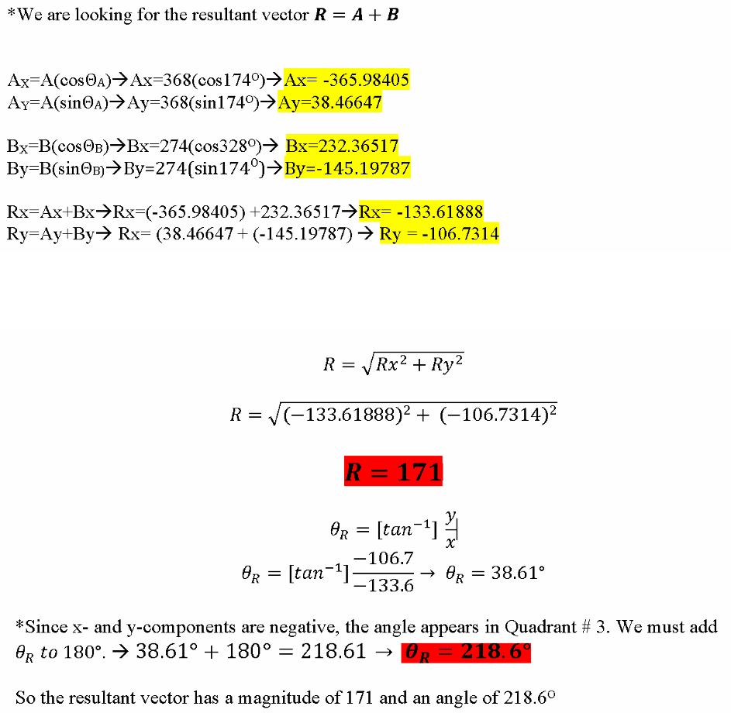

Problem 2. Do not round until the final answer, round to one decimal place.
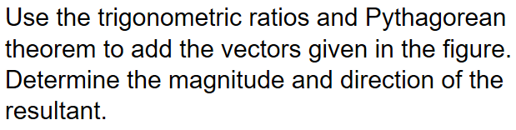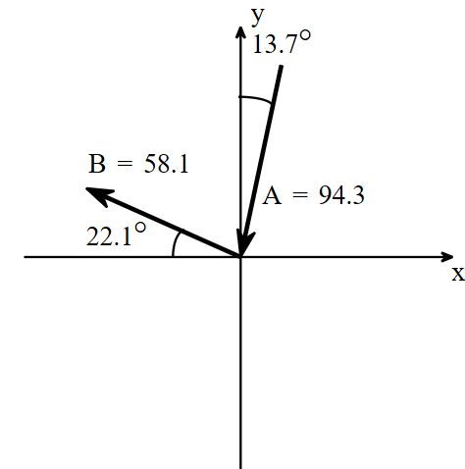
is…
Problem 3. The weight W of the crane is… pounds. The tension H in the horizontal rope is… pounds. 